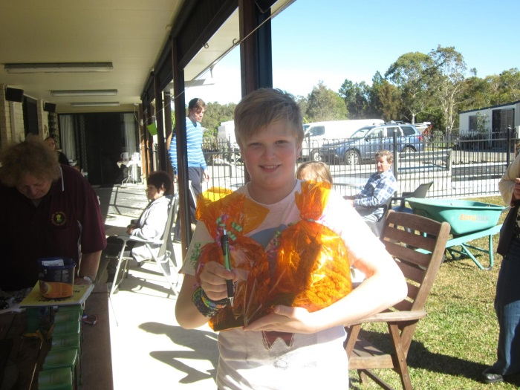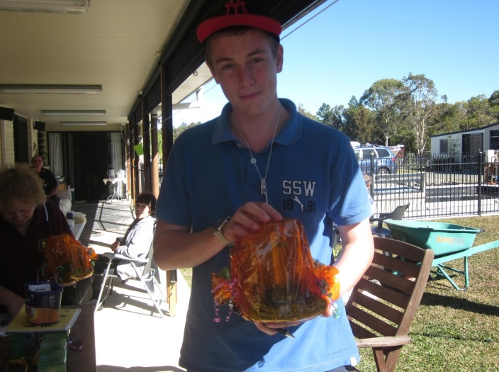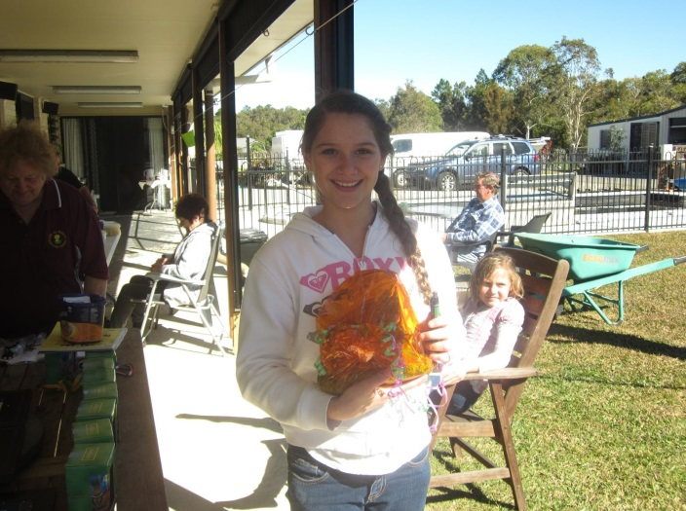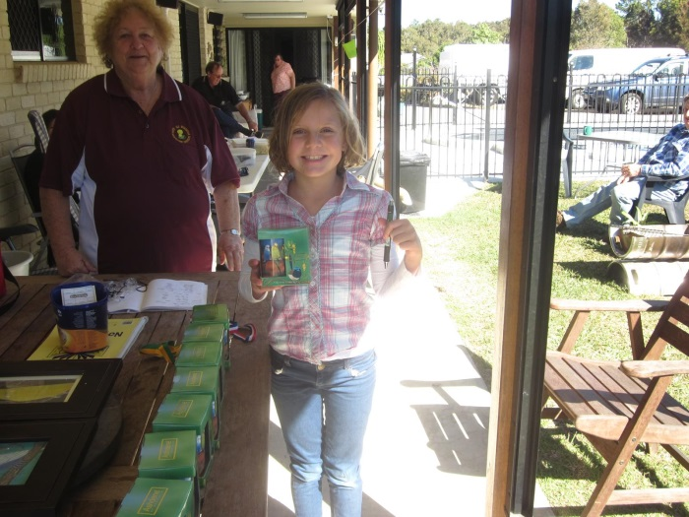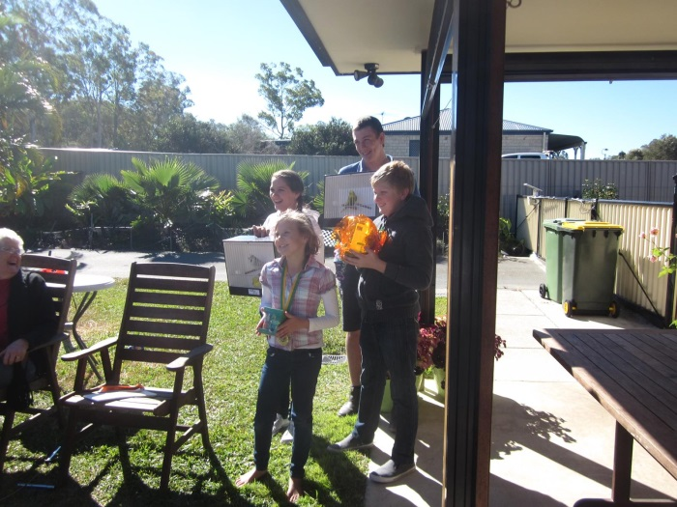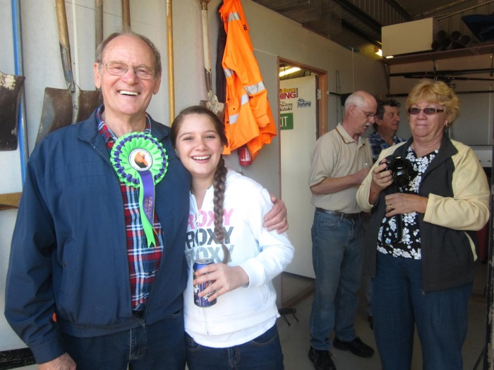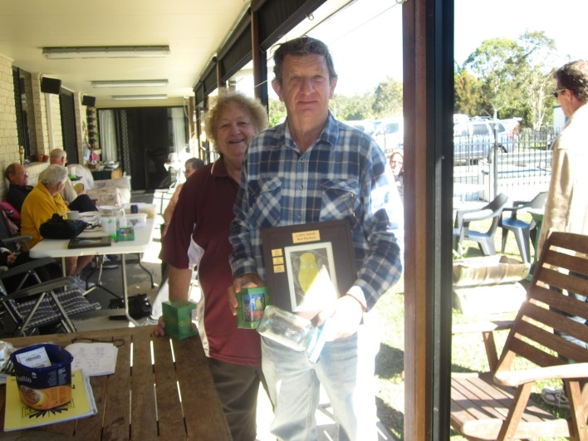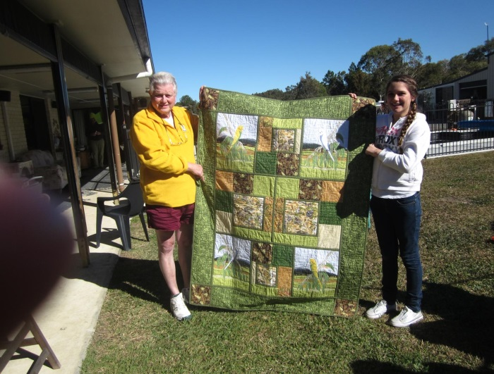

Peter Schellbach has supported from the start and won again

What a surprise – clearwings – wonderful Jacky

Very happy Anna who won a cupla awards

Sophie won some too Bobbie Budgie judged Em

Congratulations to Alex who also did well

Riley did very well in his first Lawn Show

Young Bill with Sophie – Heather, Peter & Phil

Congratulations to the Juniors who did well