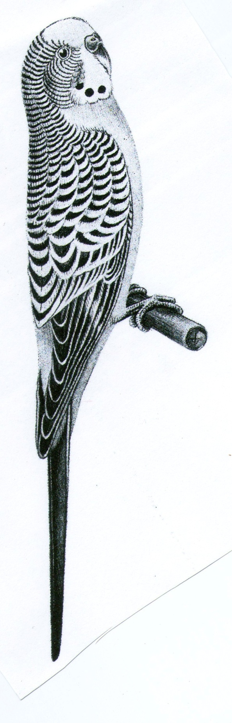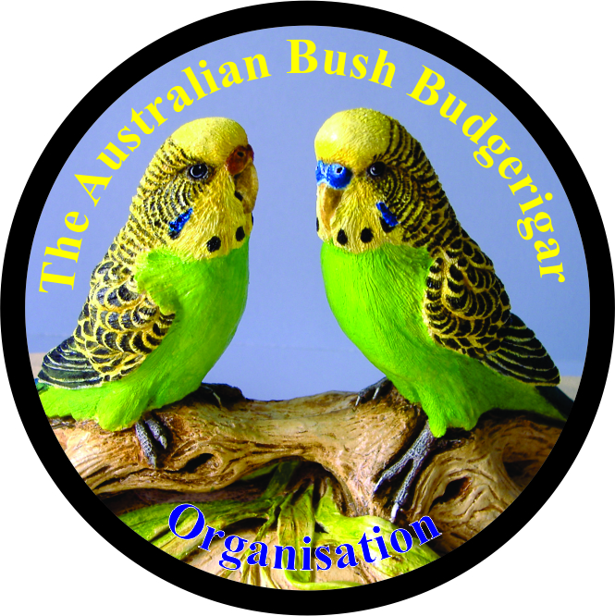

**AUSSIE BUSH BUDGERIGAR ORGANISATION ( ABBO )**

The picture above is the ideal style of bird ABBO is looking for when these are Judged at Shows ...

It is recommended that one class be reserved for the original Light Green Bush Budgie and another class or classes to be for mutations of colour and variety in the Bush Budgie ...

The clear wing pattern, six spots ( no plucking allowed ), active, clean and healthy appearance, free of injury and disease are paramount show features when awarding prizes for excellence.

The ideal length is 170 mm, especially for UBCs, but larger when older, size is not considered a major fault, at this time..... getting them on the bench is the priority and with a colour range to view

